1.Write a Java program to print "Hello, World!" to the console.

-

package demo;

public class star {

public static void main(String[] args)

{

System.***out***.println("hello world");

}

}

Output-

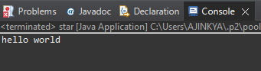

---------------------------------------------------------------------------------------------------------------------------

2.Write a program to find the sum of two numbers entered by the user.

package demo;

import java.util.Scanner;

public class om

{

public static void main(String[] args)

{

int a,b,c;

Scanner t=new Scanner(System.***in***);

System.***out***.println("1stnumber=");

a=t.nextInt();

System.***out***.println("2ndnumber=");

b=t.nextInt();

c=a+b;

System.***out***.println("a+b="+c);

}

}

Output- 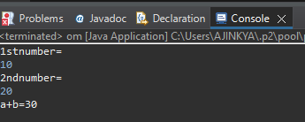

------------------------------------------------------------------------------------------------------------------------------------

3.Write a Java program to check whether a given number is even or odd.

-

package demo;

import java.util.Scanner;

public class ritesh {

public static void main(String[] args)

{

int a;

Scanner t=new Scanner(System.***in***);

System.***out***.println("enter the number=");

a=t.nextInt();

if(a%2==0)

{

System.***out***.println("Even");

}

else

{

System.***out***.println("odd");

}

}

}

Output-

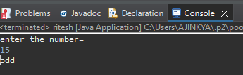

--------------------------------------------------------------------------------------------------------------------------------------

4.Write a java program to find greatest of 2 numbers.

-

package demo;

import java.util.Scanner;

public class largenumber {

public static void main(String[] args)

{

int n1,n2;

Scanner s=new Scanner(System.***in***);

System.***out***.println("Enter 1st no=");

n1=s.nextInt();

System.***out***.println("Enter 2nd no=");

n2=s.nextInt();

if(n1%n2<1)

{

System.***out***.println(n1+""+ "Is the largest number");

}

else

{

System.***out***.println(n2+" "+ "Is the largest number");

}

}

}

Output-

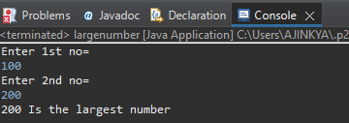

--------------------------------------------------------------------------------------------------------------------------------------

8.Write a Java program that takes an age input from the user and determines if they are eligible to vote (considering the legal voting age).-

package calculater;

import java.util.Scanner;

public class vote {

public static void main(String[] args)

{

int a;

System.***out***.println("Enter the age of voter=");

Scanner s=new Scanner(System.***in***);

a=s.nextInt();

if(a>=18)

{

System.***out***.println("voter is eligible");

}

else

System.***out***.println("voter is not eligible");

}

}

Output-

